Controlling LED with Bluetooth Module

Apparatus:1. Arduino Uno

2.Bluetooth Module

3.Wires

4.Resistor

5.Bread Board

6.LED

Procedure:

1. Take a Bluetooth Module and LED in breadboard.
2. Connect Vcc(3.3v) of Arduino to Bluetooth Module Vcc and connect GND to Bluetooth Module GND.
3. Now connect RX (Pin 0) of Arduino to TX of Bluetooth Module.
4. Now connect TX (Pin 1) of Arduino to RX of Bluetooth Module.
5. Take a LED and connect the GND with GND of arduino.
6. Attach resistor of(220Ω – 1KΩ) to Vcc of LED. And connect with pin-13 of arduino.
7. Now write the code and uplode to arduino uno.
8. Now connect the bluetooth module with your moblie bluetooth module password is (0000 or 1234).
9. Or open the serial moniter and give the command to the arduino.
10. The commands press ‘1’ to ON the LED and ‘0’ to OFF the LED.

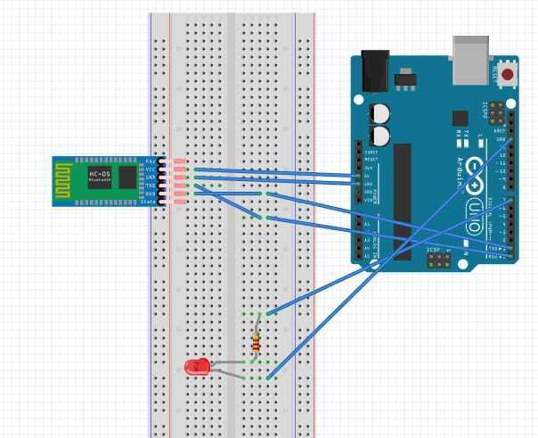

ARDUINO CODE:

char data = 0;

void setup()

{

Serial.begin(9600);

pinMode(13, OUTPUT);

}

void loop()

{

if(Serial.available() > 0)

data = Serial.read();

Serial.print(data);

if(data == '1')

{

digitalWrite(13, HIGH);

}

Else

{

if(data == '0')

{

digitalWrite(13, LOW);

 }

}

PRECAUTIONS:

1. while uploding the code remove the TX and RX pins of arduino.
2. Passwords of the bluetooth module is (0000 or 1234).

RESULT:

You can see the LED turn on when you give command(‘1’) and turn off when you give command(‘0’).

